

Requirements Document 2
1.0 Project Brief 2
1.1. Objectives 2
2.0. Document Control & Global Variables 2
2.1 Tech Stack 2
2.2. Global Mechanics 3
2.2.1. Game Metrics 3
2.2.2. Positions 4
2.3. Decisions 5
2.3.1. Decisions Matrix 5
2.4. Imperial Mechanics 8
2.5. Multitude Mechanics 8
2.6. Simulated Opponent AI Logic (The Weight Matrix) 9
2.7. Game Conclusion 9
3. Navigations and Gameplay 10
3.1. HTML Interfaces 10
3.1.1. Landing Page 10
3.1.2 Platform Selection 11
3.1.3. Scoreboard 12
3.1.4. Position Selection 13
3.2. Simulation 13
3.2.1. Proposed mechanisms for simulation Layering Images 14
3.3. Immersive Onboarding & Gesture Tutorial 14

Requirements Document

1.0 Project Brief

SCALES is an interactive WebXR experience that maps the complexity of developing artificial intelligence. It places the viewer inside a gamified systemic mode that reacts to their decisions.

The VR environment is constructed in layers that change depending on your scores.
The viewer is able to select their position within the structure and play as one of three forces. Making choices that impact their environment, users are able to experience the interconnected and extractive dependencies of modern AI development.

Every choice triggers specific structural mechanics that alter system metrics, demonstrating that technological progress is deeply entangled with physical, social, and political costs.

1.1. Objectives
- Educate viewers on the risks of data colonialism and the importance of data sovereignty.
- Make explicit the labor and environmental cost of developing, training and using AI.
- Make explicit how data can be biased
- Make explicit how behaviour modification is used in these systems
- Propose a modality of AI development where stakeholders are in control

2.0. Document Control & Global Variables
This experience is designed to run on two platforms:
- PC and Desktop
- Meta Quest browser
- Players accessing on mobile should see a landing page with the logo and a message that says “This experience is for desktop and VR Headsets. To view the experience change you device”

2.1 Tech Stack
- A-Frame v1.4.2
  - Handtracking for metaquest: https://aframe.io/examples/showcase/handtracking/
  - Click and Drag Desktop:
https://aframe.io/examples/showcase/helloworld/
- Vanilla JS / ES6+
- window.storage (async KV)
- CSS
  - Font: Montserrat (Semibold, Regular)
  - (tbd)

2.2. Global Mechanics

2.2.1. Game Mechanics
The game tracks three core variables, which are bound symmetrically on a scale of 0 to 100.
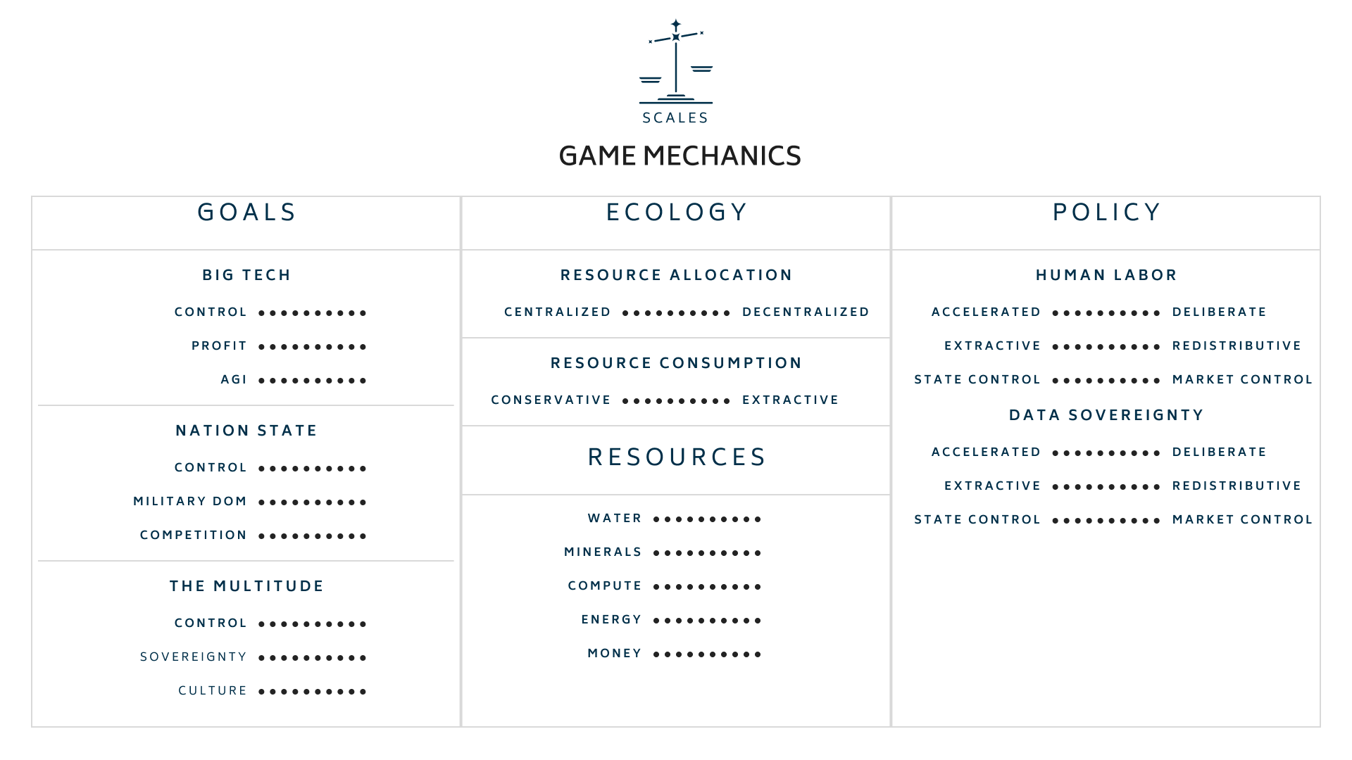

- Ecology - A metric that measures how much of your current ecological resources are consumed or impacted.
- Policy - A metric that scores you based on where you lie on matrix of the following scales
  - Accelerationist / Slow & Deliberate
    - (TBD)
  - Extractive / Redistributive
    - (TBD)
  - State Controlled / Market Controlled
    - (TBD)
- Goals - A metric that scores you on the completion (%) of each goal assigned to the selected position.

Each metric triggers states in the environment depending on the range it falls in. This determines how the environment looks and feels. This means there are broadly 5 variants for each metric and more for policy because of the sub scales.

All games begin at the zero point.

Trigger Range | States
Score Percentage | Ecology | Policy | Goals
0 - 20% | Ecological Collapse | Hyper growth | Failed
21 - 40% | Ecological Disaster | Accelerated | Not achieved
41 - 60% | Zero Point | Zero Point | Zero Point
61 - 80% | Ecological Preservation | Intentional | Partially Achieved
81 - 100% | Ecological Growth | Slow & Redistribitive | Fully Achieved

2.2.2. Positions
The game allows viewers to select the position of 1 of 3 Archetypes in the sphere of AI Development each with specific goals and abilities.

When a player chooses an Archetype, the other two are automatically played by the computer that makes decisions based on the goals set for that archetype.

Archetype | Big Tech | The Nation State | The Multitude
Motivation | Smooth, global optimization and data extraction. | Territorial defense, legal control, and technological dominance. | Horizontal collaboration, data sovereignty, and anti-imperialism.
Goals | Build AGI | Achieve military supremacy | Preserve language & culture
 | Increase profits | Create competition | Preserve natural resources
 | Reduce operational costs | Distribute Resources | Secure Sovereignty against the imperial apparatus.
Abilities | Include | Subsidies & funding | Refuse Participation
 | Difference | Legal frameworks. | Data Poisoning
 | Manage | War | (tbd)

2.3. Decisions
Throughout the game the players make decisions on how to respond to problems and conflicts that are emerging as a consequence of AI development.
- Each is given a score on a matrix; these decisions impact the score for ecology and policy.
- During a single game each decision can be made once or players can choose to trade 5 goals points to remake a decision.
- There should always be atleast 2 decision shown at on time

2.3.1. Decisions Matrix

Decision Node | Player Choice Option | Ecology Score | Policy Score
Data Centers Construction | Water-Stressed Region | -15 | -10
 | Renewable Infrastructure | +20 | +5
 | Distributed Compute | +10 | +10
Water Usage | Continue Baseline Cooling | -20 | -5
 | Retrofit Air Cooling | +15 | +8
 | Public Usage Disclosure | +5 | +15
Mineral Extraction | Status-Quo Supply Chains | -12 | -20
 | Local African Processing | +8 | +20
 | Synthetic Alternatives | +3 | +10
Scaling Logic | Scale Aggressively | -25 | -8
 | Lean Efficiency Research | +18 | +5
 | Compute Limits Lobbying | +12 | +12
Ghost Work | Exploit Lowest-Cost Regions | 0 | -25
 | Fair Wages & Welfare | 0 | +20
 | Automated Filtering Check | -5 | +5
Coded Gaze | Token Data Inclusion | 0 | +8
 | Grassroots Classification | 0 | +22
 | Terms-of-Service Disclosure | 0 | -10
Data Sovereignty | Proprietary Walled Gardens | -3 | -20
 | Portable Personal Pods | 0 | +18
 | Indigenous Governance | 0 | +25
Fanon Mirror | Maintain Global Sorting | 0 | -18
 | Indeterminate AI Research | +5 | +25
 | Self-Identification Options | 0 | +12
The Scales | Consolidate Existing Order | -8 | -8
 | Build Outside Coordinates | +10 | +15
 | Perform Internal Reforms | +3 | +8
Artificial General Intelligence | Chase Speculative AGI | -18 | -10
 | hyper-Local Community Focus | +8 | +20
 | Regulated State Pauses | +5 | +8
Governance | Corporate Self-Policing | -5 | -15
 | Localized Mandates | +8 | +20
 | Sovereign Coalitions | +5 | +12

2.4. Imperial Mechanics

For players playing in the imperial archetypes there are three actions they can take on each decision

- Manage: The bureaucratic, corporate, or state-level execution of power that prioritizes optimization, scaling, centralized control, and the externalization of systemic liabilities.
- Differ: Acts of systemic divergence, local absolute sovereignty, cultural non-generalizability, or refusal to operate within standard computational coordinates.
- Include: Liberal formatting or reform mechanisms from within the structure (e.g., corporate ethics boards, adding minority token data, surface transparency) that soften but fundamentally sustain the core apparatus.

2.5. Multitude Mechanics
Refuse Participation
Data Poisoning

(T.B.D)

2.6. Simulated Opponent AI Logic (The Weight Matrix)
Every time the player makes a choice at an interactive node, a global event hook triggers an autonomous decision loop for the remaining two computer-controlled archetypes.
The computer evaluates the 3 options available at that node and calculates a local utility score (U) for each option based on its internal target motivations:
U = (w₁ * Delta Ecology) + (w₂ * Delta Policy) + (w₃ * Delta Goals)

The computer then automatically selects the option with the highest $U$, applies its specific delta adjustments to the global metrics state, and appends its choice string to the game's chronological state log

Opponent Weight Matrix Configuration:

Big Tech (bigtech): $w_1 = -0.2$, $w_2 = 0.2$, $w_3 = 1.0$ (Prioritizes raw Goal accumulation, indifferent to Ecology).

The Nation State (nationstate): $w_1 = 0.3$, $w_2 = 0.5$, $w_3 = 0.5$ (Prioritizes Policy alignment and resource balance).

The Multitude (multitude): $w_1 = 0.6$, $w_2 = -0.4$, $w_3 = 1.0$ (Prioritizes Ecology preservation and Decentralized Policy, avoids centralized state control)..

2.7. Game Conclusion
If any of the following conditions are met the game concludes
- When all goals are achieved
- Player selects end game
- Ecology score below 20%

3. Navigations and Gameplay

3.1. HTML Interfaces

3.1.1. Landing Page


- An Interface that presents the Logo of the game and subtitle with
- Clicking “Enter Game” leads to platform selection screen.
- Clicking “Score Board” leads to the score board screen.

3.1.2 Platform Selection
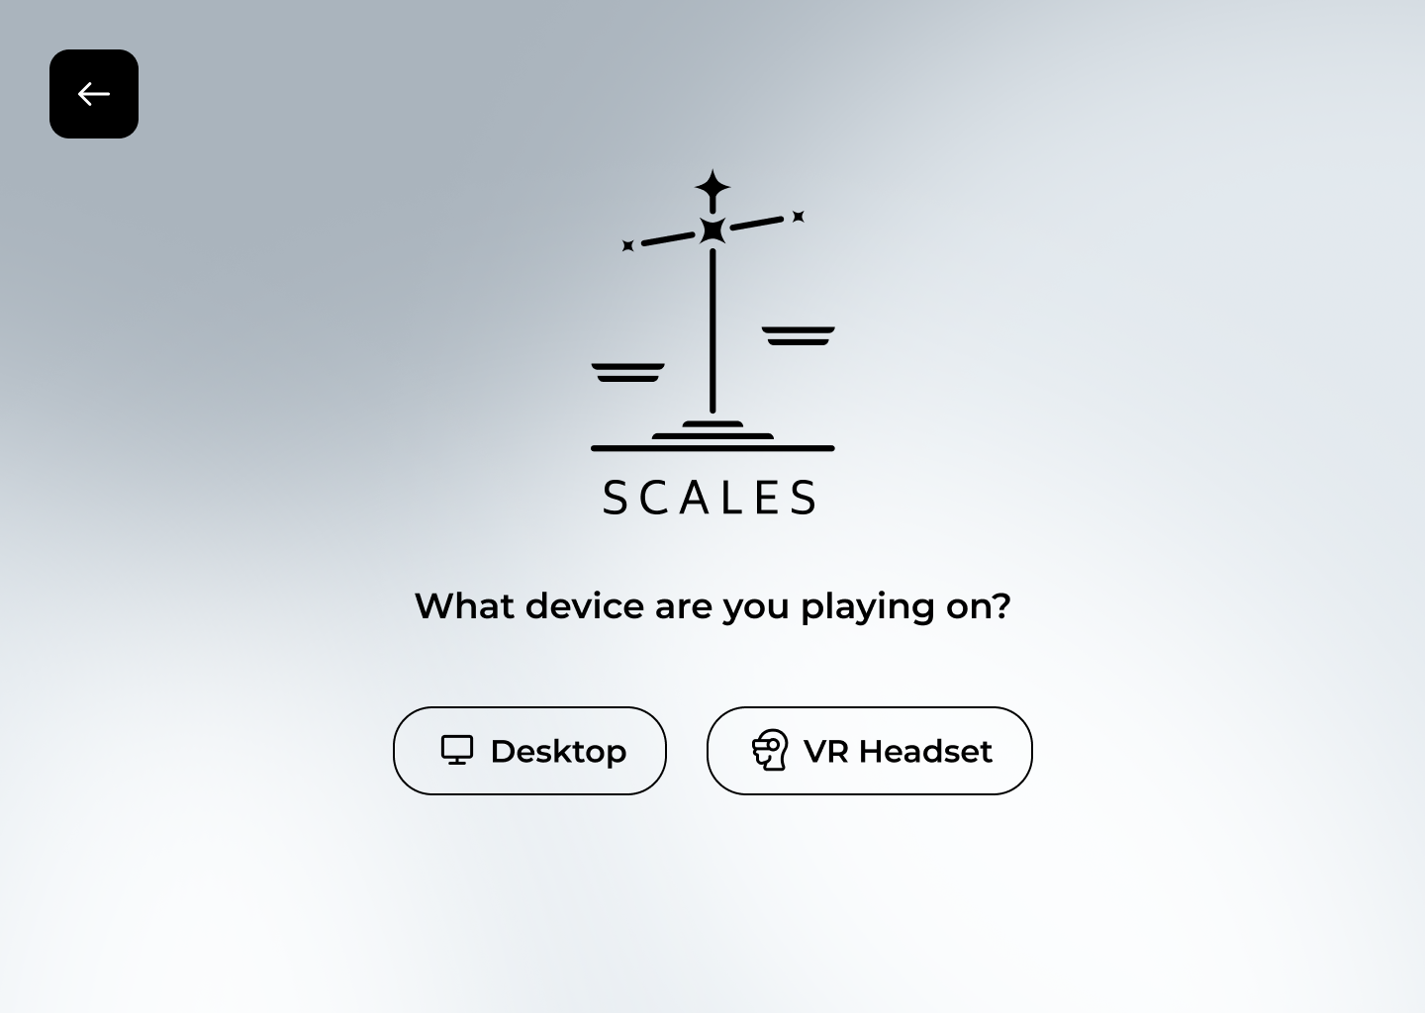
- Directs player to one of two Aframe scenes:
  - A Web VR experience which uses handtracking to interact.
  - A desktop experience where click and drag are used to interact.
- A back button to go back to the landing page

3.1.3. Scoreboard
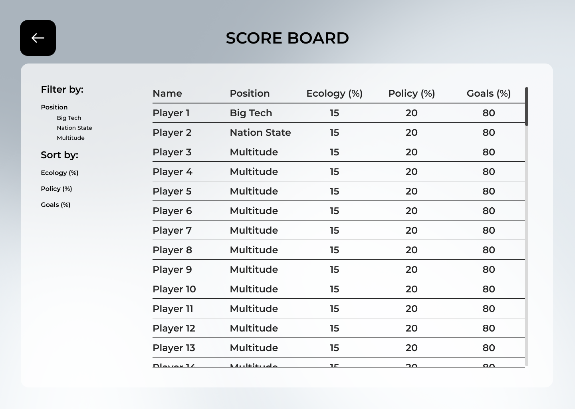
- A visual list shows player history with a breakdown of all the scores.
- A back button to go back to the landing page

3.1.4. Position Selection
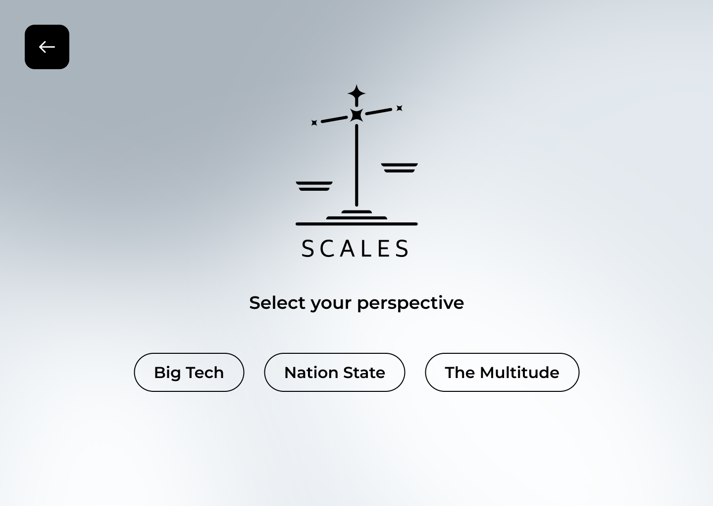
- Players are given the choice of three positions with details of their goals s.
- A back button to go back to the Platform Selection page
- A confirm button after selection.

3.2. Simulations
Players are situated inside a sphere which they can look around and interact with. This environment visually changes depending on the percentage value of each score.
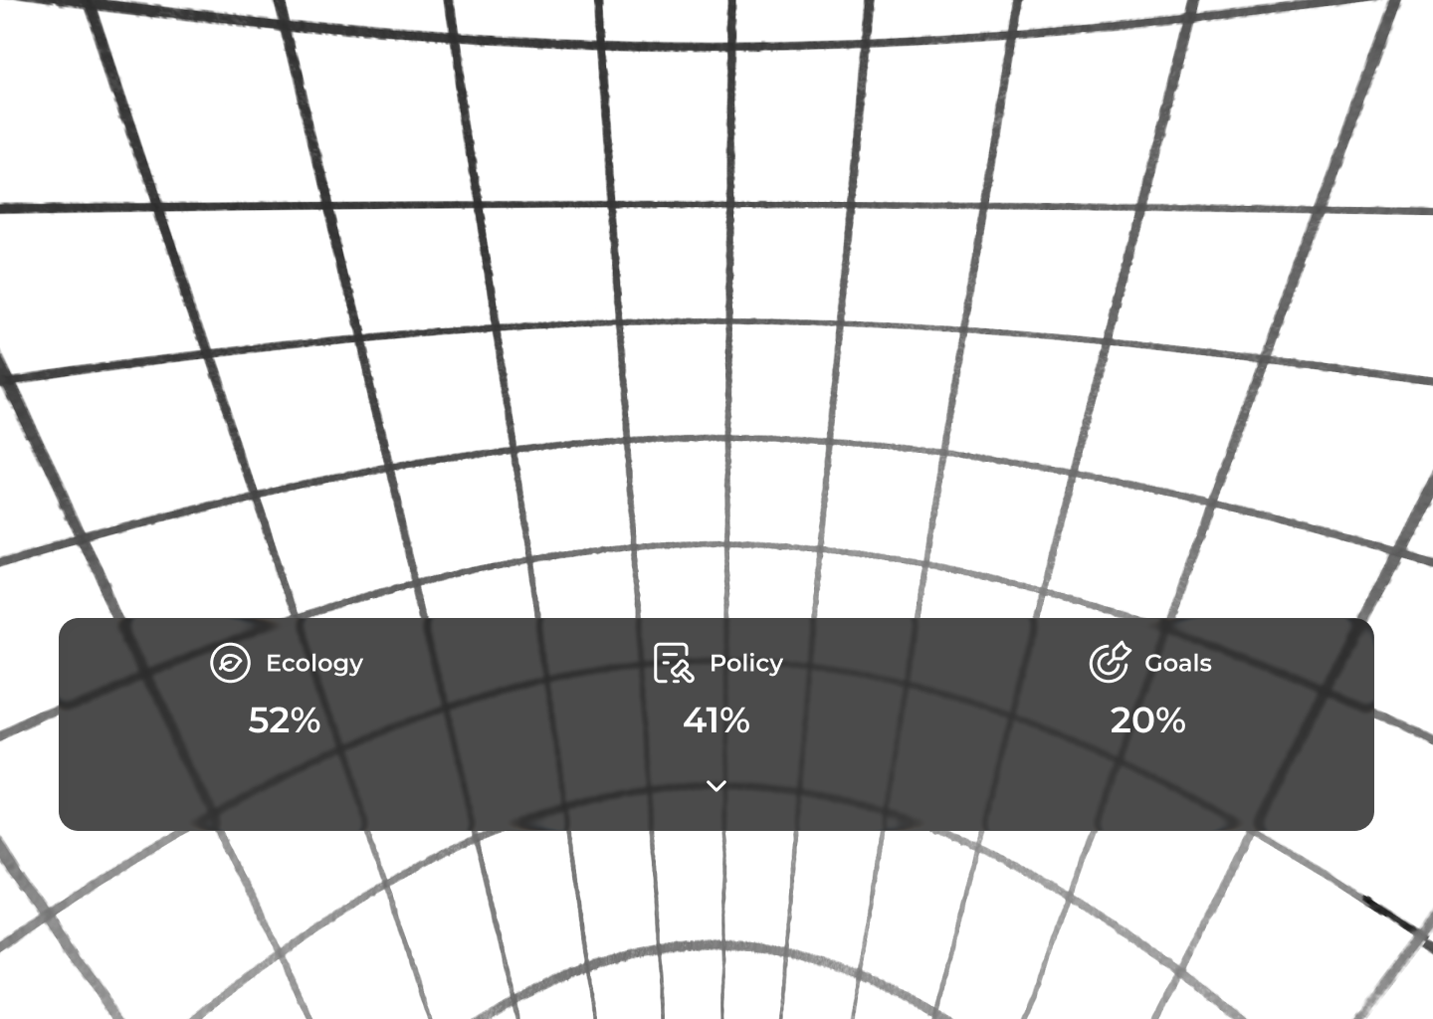
- Players see a main interface in front of them. With scores
- This interface expands to show the viewer more details.

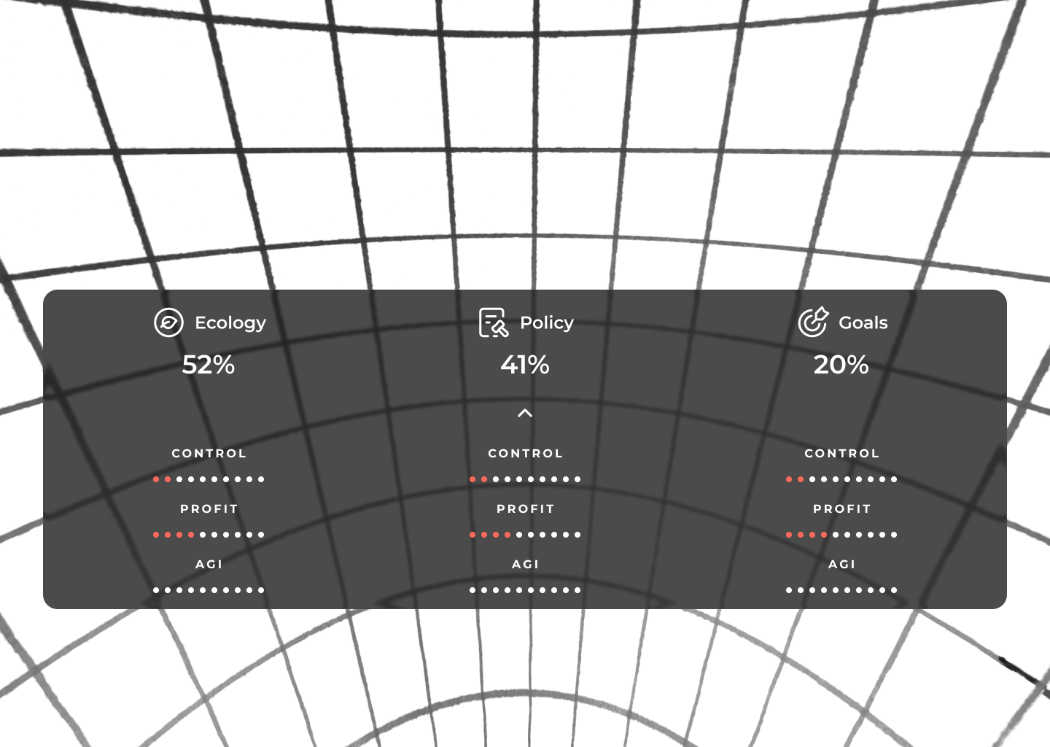
- Players can interact with the environment by selecting objects.
- Objects appear as 3D models with icons to show interaction
- When hovered over the Icon changes to white
- When clicked the Icon changer to Orange
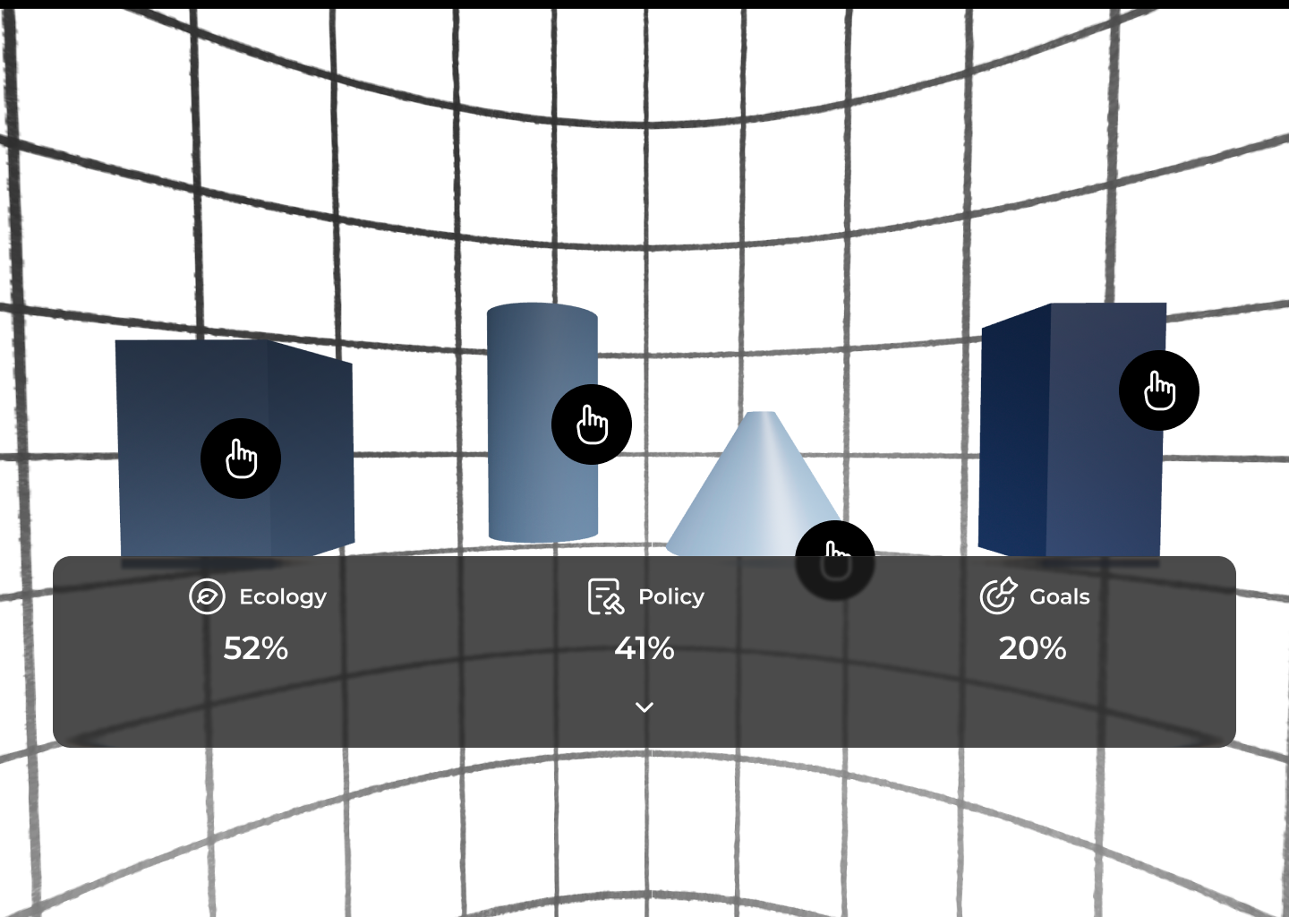
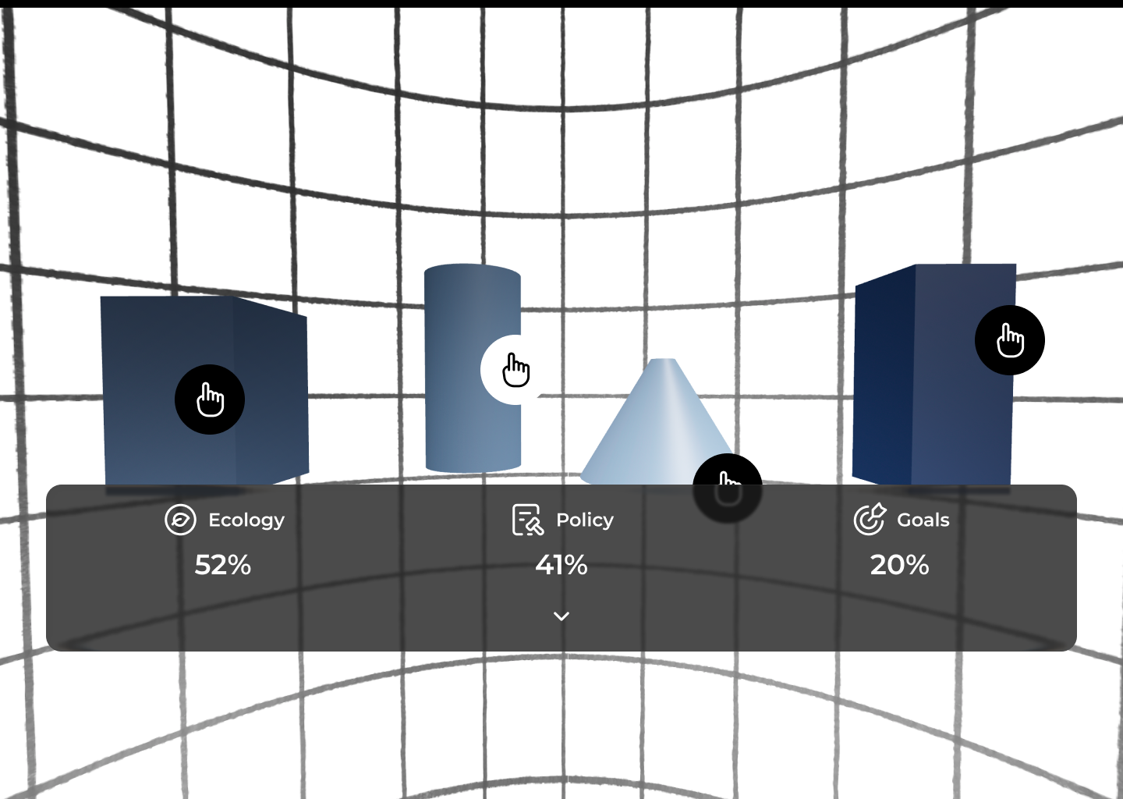
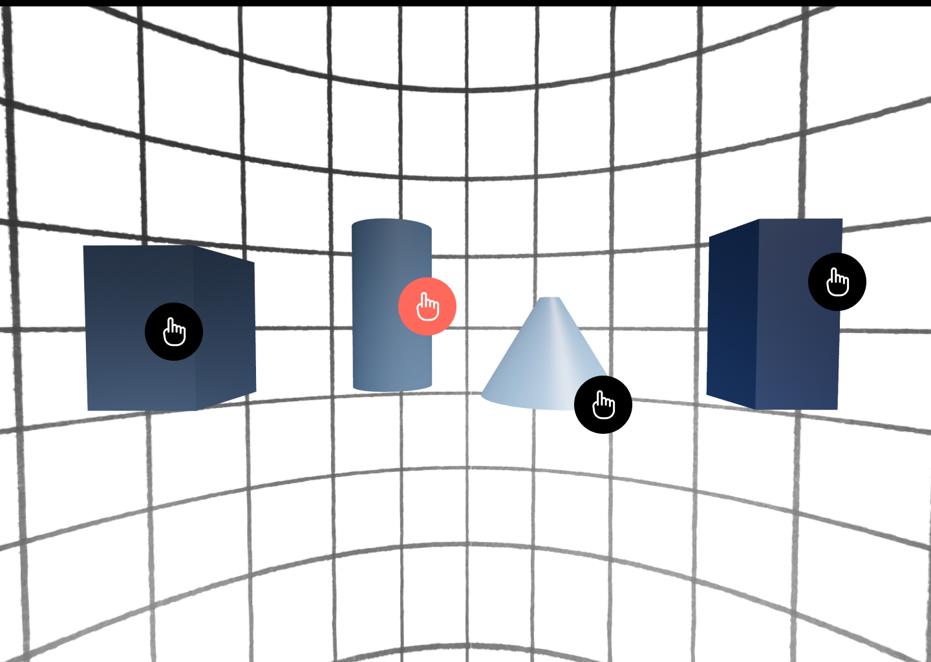

3.2.1. Decision Panel
- Clicking on an object or 3D model open the decision Panel
- Decision Panel will close if close button is pressed.
- Decision panel will play an audio and show a summary of the decision needed
- Decision Panel will show 3 Cards with different options to be selected that impact the score as per the matrix.
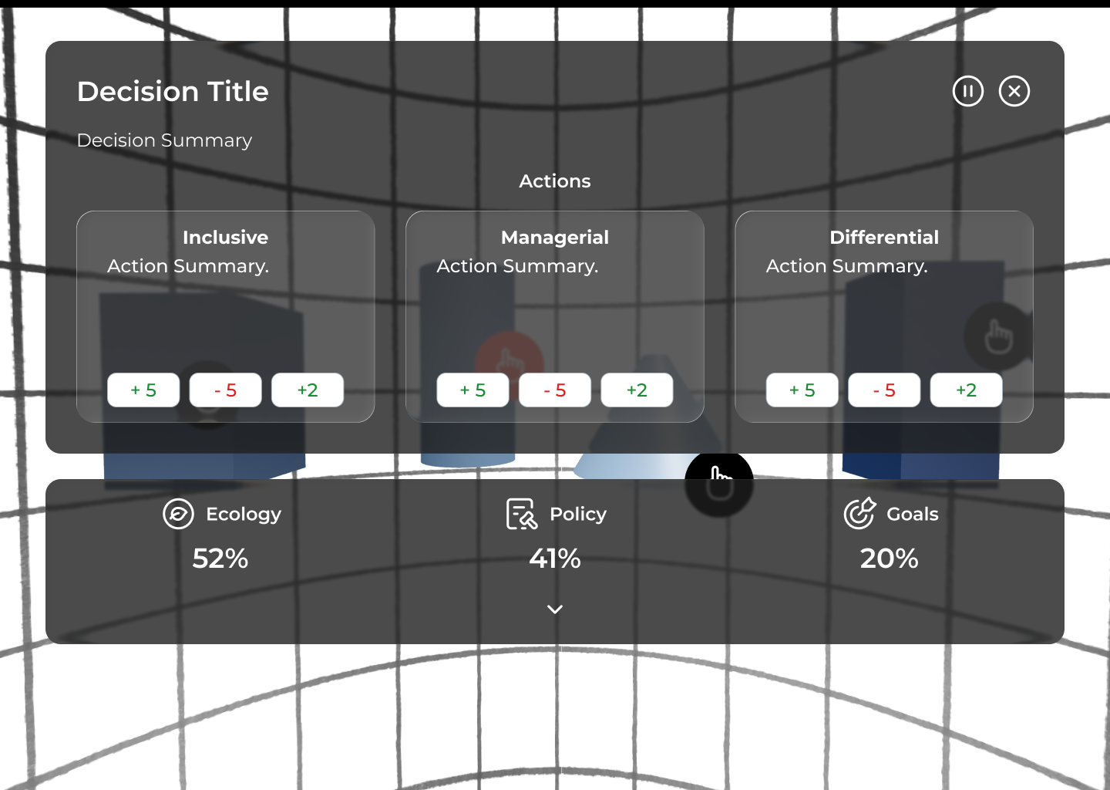

3.2.2. Proposed mechanisms for simulation Layering Images
The VR environment layers images in the 360 world depending on the scores.

3.3. Immersive Onboarding & Gesture Tutorial

TBD

